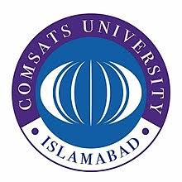
COMSATS UNIVERSITY ISLAMABAD
ABBOTTABAD CAMPUS
RECEIVING FORM
Final Transcript and Degree
It is certified that I have received my Final Transcript/Degree bearing No. _________________. I have checked the contents of transcript and degree (i-e Name, Father’s Name, Gender, Courses and CGPA etc) and found correct to the best of my knowledge.

Mr. / Miss____________________________ S/D/O __________________________________

Reg #_______________________________ Ph #____________________________________

Mobile #_____________________________ CNIC #__________________________________

Student Signatures_____________________

Student’s Affairs Official Signature_______________ Exam Official Signature______________

Date:______________________

