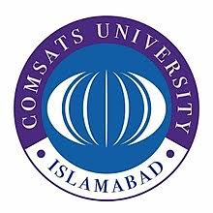
COMSATS UNIVERSITY ISLAMABAD
ABBOTTABAD CAMPUS

RECEIPT MERIT CERTIFICATE

I received my Merit Certificate bearing No. _________________________ of ___________
(Program Name)
from Examination Department on _________________________.

Mr. / Miss____________________________ Reg #_______________________________

Present Mailing Address:_________________________________________________________

______________________________________________________________________________

Ph #_______________________________ Mobile #___________________________________

NIC #________________________________ Student Signatures____________________

AR (SA) Official Signature________________ Exam Official Signature________________

Date:______________________

